Mex-Colima-Shaft Tomb Fig

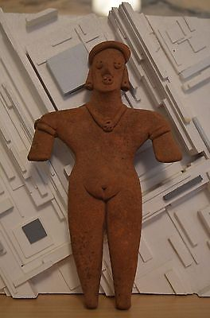

#### [Pre-Columbian Colima Mexico Shaft Tomb Figure 200 BC - AD 250](http://www.ebay.com/itm/151862039426)

|  |  |
| --- | --- |
| Item price | $110.00 |
| Quantity | 1 |
| Item number | 151862039426 |
| Shipping service | Standard Shipping |

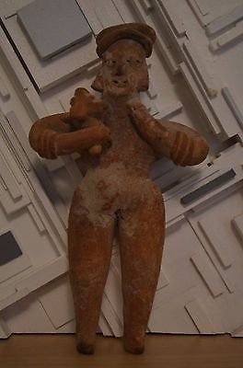

#### [Pre-Columbian Colima Mexico Shaft Tomb Figure 200 BC - AD 250](http://www.ebay.com/itm/151862039930)

|  |  |
| --- | --- |
| Item price | $110.00 |
| Quantity | 1 |
| Item number | 151862039930 |
| Shipping service | Standard Shipping |

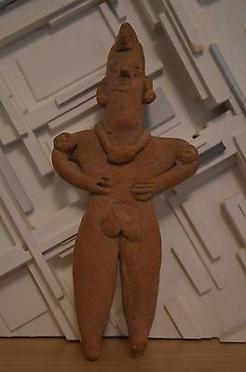

#### [Pre-Columbian Colima Mexico Shaft Tomb Figure 200 BC - AD 250](http://www.ebay.com/itm/151862040300)

|  |  |
| --- | --- |
| Item price | $99.99 |
| Quantity | 1 |
| Item number | 151862040300 |
| Shipping service | Standard Shipping |